|  |  |  |  |  |  |  |  |  |  |  |  |  |  |  |  |  |  |  |  |  |  |  |  |  |  |
| --- | --- | --- | --- | --- | --- | --- | --- | --- | --- | --- | --- | --- | --- | --- | --- | --- | --- | --- | --- | --- | --- | --- | --- | --- | --- |
| **FORMULIR AKUISISI PROPERTI GEDUNG / HRB – MNC Play** | | | | | | | | | | | | | | | | | | | | | | | | | |
| Nama Properti | | |  | | | | | | | | | | | | | | | | | | | | | | |
| Nama Perusahaan/Pengelola | | |  | | | | | | | | | | | | | | | | | | | | | | |
| Alamat | | | RT. RW. Kec.  Kel. Wil. Kota | | | | | | | | | | | | | | | | | | | | | | |
| Koordinat | | |  | | | | | | | | | | | | | | | | | | | | | | |
| Status Bangunan | | | Existing /Sdh Terbangun | | | | | | | | | | | | | | | Harga Sewa/m2 (*termasuk semua biaya*) | | | | | | | |
| On Progress/Dlm Pembangunan | | | | | | | | | | | | | | | Rp./USD __________________________ | | | | | | | |
| Jumlah Tower | | | 1 | | | | 2 | | | 3 | | | 4 | | 5 | | | 6 | | | Keterangan | | | | |
| Jumlah Lantai | | |  | | | |  | | |  | | |  | |  | | |  | | |  | | | | |
| Jumlah Unit | | |  | | | |  | | |  | | |  | |  | | |  | | |  | | | | |
| Jumlah Unit tersewa | | |  | | | |  | | |  | | |  | |  | | |  | | |  | | | | |
| Tingkat Okupansi | | |  | | | |  | | |  | | |  | |  | | |  | | |  | | | | |
| Infrastruktur Yang Ada | | | Coaxial FTTH ADSL UTP Belum Ada | | | | | | | | | | | | | | | | | | | | | | |
| Main Hole Ready | | | YA TIDAK | | | | | | | | | | | | | | | | | | | | | | |
| Pembangunan Infrastruktur s/d. | | | Control Room Shaft (FAT) | | | | | | | | | | | | | | | | | | | | | | |
| Internet Service | | | Dedicated Broadband | | | | | | | | | | | | | | | | | | | | | | |
| Layanan Yang Disediakan MNC | | | Internet IPTV Telephony* | | | | | | | | | | | | | | | | | | | | | | |
| Mayoritas Jenis Usaha (*pilih dan isi dengan angka sesuai kondisi dilapangan*) | | | | | | | | | | | | | | | | | | | | | | | | | |
| Distributor ( ), Resto/Cafe ( ), Bank ( ), Mini Market /Apotek ( ), Tour & Travel ( )  Lembaga Pendidikan ( ), Konsultan Non legal & Legal ( ), Modern Market /Hyper Store ( ) ATPM/Principle ( ), Expedisi ( ), Agency ( ) | | | | | | | | | | | | | | | | | | | | | | | | | |
| Others : | | | | | | | | | | | | | | | | | | | | | | | | | |
| Pengelola berkenan untuk membantu penjualan? Ya Tidak | | | | | | | | | | | | | | | | | | | | | | | | | |
| Berapa harga rata-rata berlangganan internet per-bulan Rp. | | | | | | | | | | | | | | | | | | | | | | | | | |
| **Provider Existing** | | | | **Berikan tanda cek list** | | | | | | | **Eksklusif** | | | | | **Durasi Kerjasama s/d. Bln/Thn** | | | | | | **Skema Kerjasama** | | | |
| **Inet** | | **TV** | | | **Telp.** | | **Y** | | | **N** | | **Rev.Share (%)** | | **Sewa**  **(Rp.)** | |
| 1. |  | | |  | |  | | |  | |  | | |  | |  | | | | | |  | |  | |
| 2. |  | | |  | |  | | |  | |  | | |  | |  | | | | | |  | |  | |
| 3. |  | | |  | |  | | |  | |  | | |  | |  | | | | | |  | |  | |
| 4. |  | | |  | |  | | |  | |  | | |  | |  | | | | | |  | |  | |
| 5. |  | | |  | |  | | |  | |  | | |  | |  | | | | | |  | |  | |
| **Skema kerjasama dengan MNC Play** | | | | | | | | | | | | | | | | | | | | | | | | | |
| Status Kerjasama/Periode | | | | Exclusive Non Exclusive Thn | | | | | | | | | | | | | | | | | | | | | |
|  | | | | | | | | | | | | | | | | | | | | | | | | | |
| **Aktifitas Sales & Marketing Tools** | | | | | | | | | | | | | | | | | | | | | | | | | |
| Penempatan/Pemasangan/  penyebaran Marketing Tools | | **Lobby & Receptionist** | | | | | | **Area Parkir** | | | | **Pintu Parkir in/out** | | | | | **Mktg. Office** | | | **Pubik Area** | | | **Door to Door** | | **Kantin** |
| Aktifitas preselling (jika Ya) | |  | | | | | |  | | | |  | | | | |  | | |  | | |  | |  |
| Aktifitas Sales Probing | |  | | | | | |  | | | |  | | | | |  | | |  | | |  | |  |
| Pameran & Pop Up Table *(terlampir)* | |  | | | | | |  | | | |  | | | | |  | | |  | | |  | |  |
| Penempatan Spanduk *(terlampir)* | |  | | | | | |  | | | |  | | | | |  | | |  | | |  | |  |
| Penempatan Poster *(terlampir)* | |  | | | | | |  | | | |  | | | | |  | | |  | | |  | |  |
| X/Roll Up Banner *(terlampir)* | |  | | | | | |  | | | |  | | | | |  | | |  | | |  | |  |
| Acrilic Box /Brosur *(terlampir)* | |  | | | | | |  | | | |  | | | | |  | | |  | | |  | |  |
| Catatan: | | | | | | | | | | | | | | | | | | | | | | | | | |
| Saya yang bertandatangan menyatakan bahwa informasi ini adalah benar adanya, untuk kebutuhan follow up kerjasama yang cepat secara detail dan akurat. | | | | | MNC Play  (..................................................)  Jabatan: | | | | | | | | | | | | | | Pihak Mitra  Tgl.  (..................................................)  Jabatan:  No. Telp.  No.HP. | | | | | | |

|  |  |
| --- | --- |
| Catatan dan Rekomendasi Sales Kadept./ Kadiv.  Rekomendasi : REJECT DROP APPROVE | Jakarta, _____________________  (..................................................)  Jabatan: |

* Optional | Catatan: Beri tanda Cek (√) pada kolom pilihan dan coret yang tidak perlu

REJECT : Proyek tidak direkomendasikan secara permanen

DROP : Proyek tidak direkomendasikan namun dapat di follow up kembali

APPROVE : Proyek disetujui dan dapat dilanjutkan

**POSTER**

*Ukuran 118,9 cm x 84,1 cm*

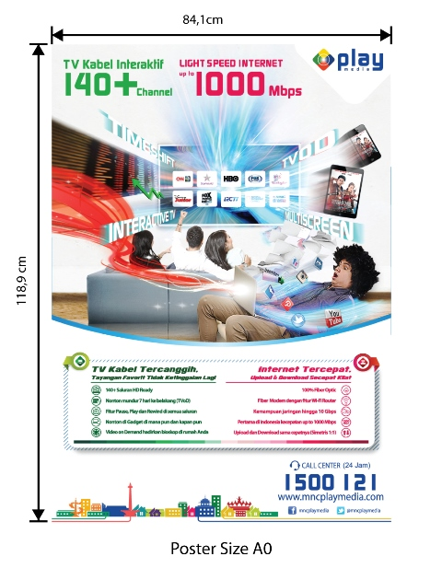

**ACRILIC BOX /Brosur**

*Ukuran 20 cm x 30 cm x 5 cm*

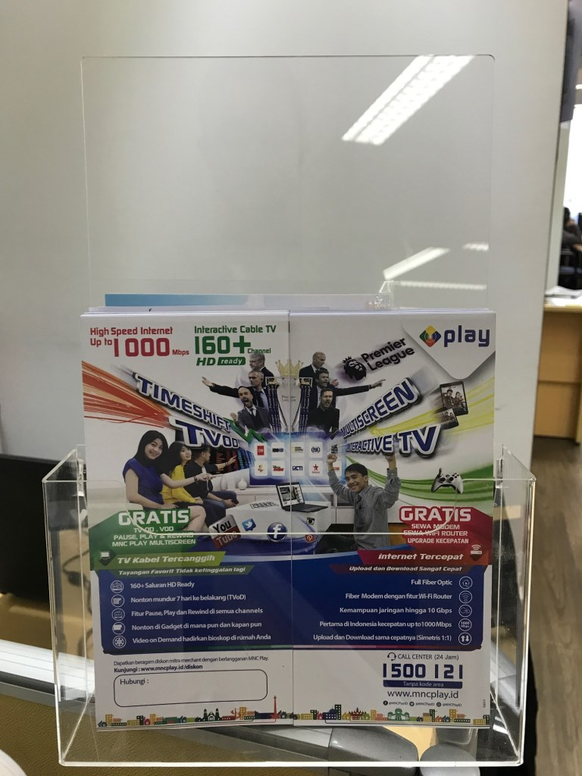

**POP UP TABLE**

*Ukuran 184 cm x 90 cm*

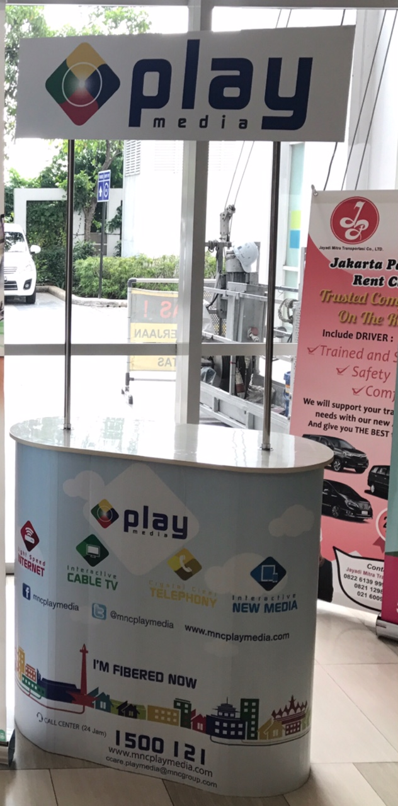

**X/ROLL UP BANNER**

*Ukuran 200 cm x 80 cm*

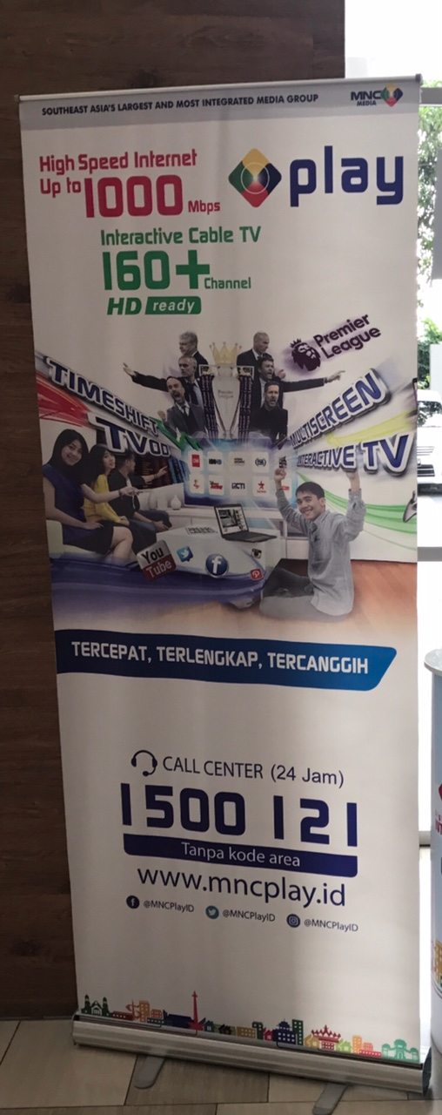

**SPANDUK**

*(ukuran 2 x 4 m / disesuaikan)*

*Catatan:*

*Design, content atau redaksi serta ukuran pada material marketing tools diatas adalah merupakan ilustrasi semata. Design, content atau redaksi serta ukuran yang akan digunakan sebagai materi promosi akan mengikuti atau disesuaikan dengan kondisi yang ada.*